 | International Journal of Advancement in Life Sciences Research  Online ISSN: 2581-4877  Journal homepage http://ijalsr.org | 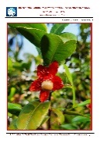
Original Article
Formulation and Evaluation of Anti-Acne Moisturizer Containing Rosehip Oil and Persea Grastissma Oil Against Staphylococcus epidermidis

Nur Aliyya Syakirin Binti Shaharuddin¹, Tavamani Balan¹, Sharon Fatinathan¹, Puvana Devi Selvarajoo¹, Vikneswari Perumal^{2*}

¹Faculty of Pharmacy and Health Sciences, Royal College of Medicine Perak, Universiti Kuala Lumpur, 30450 Ipoh, Perak, Malaysia
²School of Pharmacy, Management and Science University (MSU), Persiaran Olahraga, Section 13, 40000 Shah Alam, Selangor Darul Ehsan, Malaysia

*Corresponding Author’s Email: vikneswari_perumal@msu.edu.my

Abstract
Introduction: Avocado and rosehip oils are examples of oils that can help treat various skin conditions. On the other hand, avocado and rosehip oils are not usually found in the compositions of facial moisturizers. It is frequently used in the formulation process of skin serums. Avocado and rosehip oil possess various beneficial properties, including the treatment of wounds and skin inflammation, reduction of scars, minimization of wrinkles, and treatment of acne. This study aimed to develop and characterize a moisturizing cream formulation utilizing rosehip oil and avocado oil, and to investigate the anti-acne effect of the formulated moisturizer against Staphylococcus epidermidis. Methods: An anti-acne moisturizing cream was formulated using rosehip and avocado oil. The physicochemical properties and the stability of the cream were evaluated. The anti-acne activity of the cream was analyzed using the well diffusion method. Results: The formulations exhibited good physical properties and stability. Although a stable moisturizing cream was formulated, it lacks antibacterial activity against S. epidermidis. Conclusion: In conclusion, integrating rosehip and avocado oils into formulations holds potential for addressing acne, attributed to their antibacterial properties. The absence of antibacterial efficacy against S. epidermidis in the current formulation could be attributed to inadequate bioactive constituents. Therefore, further exploration of the optimal ratio and concentration of rosehip and avocado oil is necessary to maximize their therapeutic benefits in anti-acne formulations.

Keywords: Anti-Acne; Avocado Oil; Rosehip Oil; S. Epidermidis

Introduction
Acne vulgaris (AV) is a common, chronic form of acne that affects the skin and is characterized by blocked, inflamed, or both pilosebaceous units. This condition can affect one or both sides of the face (Tan et al., 2018; Novaryatiin et al., 2024; Xu et al., 2025). Acne usually affects the face and can occur in either inflammatory or non-inflammatory lesions, or a combination of both. According to Hafeez et al (2020), it is present in around 70% of teenagers and 10% of adults worldwide. Several pathological processes contribute to the development of acne, the most prominent of which include androgen-mediated stimulation of sebaceous gland activity, follicular hyperkeratinization, hormonal imbalance, inflammation, and external bacterial infection. Staphylococcus epidermidis (S. epidermidis) and Propionibacterium acnes (P. acnes) are the bacteria that are commonly found on the skin most frequently, and both bacteria can cause acne (Vora et al., 2018). Although both organisms are implicated, S. epidermidis was selected as the primary screening target in this study because it plays a dual and increasingly recognized role in acne-related dysbiosis. While naturally part of the normal skin flora, S. epidermidis can become opportunistic and proliferate excessively under conditions of a disrupted skin barrier (Hamann et al., 2025). Therefore, focusing on S. epidermidis provides meaningful insight into microbial imbalance during acne flare-ups and enables more targeted antibacterial screening for potential anti-acne agents.
Chien et al. (2016) have stated that due to the physiological changes that take place during pregnancy, as well as the unpredictable nature of acne at this time, acne can be a challenging issue for pregnant women who plan to get pregnant. According to Jones et al (2014), acne can become more severe during the third trimester of pregnancy due to rising levels of maternal androgens and the resulting impact on sebum production. Aside from hormonal changes, pregnancy-related immunologic variables may also play a role (Pugashetti & Shinkai, 2013). Based on a study by Dréno et al (2014), inflammatory lesions are more frequent than non-inflammatory lesions and frequently involve the trunk. The possible toxicity of the most frequent and effective acne medications to the fetus generally limits acne treatment during pregnancy. Therefore, the therapy of acne in pregnant patients can be complicated due to the contraindication or non-recommendation of several commonly used and effective treatment methods. Examples of topical therapies that can induce skin irritation and result in low treatment compliance are benzoyl peroxide, retinoids, and salicylic acid. Isotretinoin, when taken orally, is considered the most effective acne treatment and has been shown to induce side effects, including dry skin, cheilitis, and photosensitivity. Dryness and skin irritation are two factors that can lead to the breakdown of the stratum corneum barrier, contributing to increased transepidermal water loss (TEWL) and inflammation (Rau et al., 2024). Due to these side effects, some dermatologists recommend using moisturizers as an adjunct to treat acne, particularly when topical benzoyl peroxide or retinoids are used. Additionally, some evidence suggests that moisturizers can help alleviate acne symptoms (Chularojanamontri et al., 2014).
Moisturizers can provide several dermatological benefits, including antibacterial and wound-healing effects (Mawazi et al., 2022). Although many formulations exist, their ingredients may not be universally suitable. Rosehip oil, rich in unsaturated fatty acids and anti-oxidants, offers protective properties (Lin et al., 2018). Persea gratissima (avocado) oil contains oleic, linoleic, and α-linolenic acids, along with β-sitosterol, β-carotene, lecithin, and essential vitamins and minerals, making it valuable in topical applications. Therefore, this study aims to formulate and evaluate an anti-acne moisturizer containing rosehip and P. gratissima oils against S. epidermidis.

Material and Methods
Preparation of anti-acne moisturizer
Three different anti-acne moisturizers, each containing avocado and rosehip oils, were formulated according to the specifications outlined in Table 1. For formulation 1 (F1), 2.0 mL of isopropyl myristate, 3.0 mL of caprylic triglyceride, 1.0 g of shea butter, and 1.0 mL of avocado oil were transferred into a labelled beaker denoted as Beaker A. Simultaneously, in Beaker B, about 6.0 mL of glycerine, 4.0 mL of propylene glycol, 0.3 g of xanthan gum, and 1 mL of distilled water will be added. Both beakers were subjected to a water bath at 75 °C with intermittent manual stirring until the ingredients melted and were homogeneously blended. Subsequently, the contents of Beaker A were gradually introduced into Beaker B while stirring continuously to ensure thorough mixing. Carbopol, prepared in Beaker C by slowly adding 0.5 g of carbopol to 10 mL of distilled water, was then combined with the contents of Beaker B. Homogenization was facilitated using a homogenizer. The remaining distilled water was added to achieve a total volume of 100 mL, ensuring thorough mixing with a homogenizer. Finally, preservatives and fragrances were incorporated. Upon completion of formulation, 3 mL samples from each preparation were placed in centrifuge tubes for stability testing via centrifugation (Maha et al., 2017). Formulations 2 (F2) and 3 (F3) were prepared using the same method, adhering to the specified excipients outlined in Table 1.

Table 1: List of Ingredients to Prepare the Moisturizer of Formulation 1 (F1), Formulation 2 (F2) and Formulation 3 (F3)
No. | Ingredients | F1 | F2 | F3
1. | Isopropyl myristate | 2.0 mL | 2.0 mL | 2.0 mL
2. | Caprylic triglycerides | 3.0 mL | 3.0 mL | 3.0 mL
3. | Persea gratissima (avocado) oil | 1.0 mL | - | 1.0 mL
4. | Rosehip seed oil | - | 1.0 mL | 1.0 mL
5. | Xanthan gum | 0.3 g | 0.3 g | 0.3 g
6. | Glycerine | 6.0 mL | 6.0 mL | 6.0 mL
7. | Carbopol | 0.5 g | 0.5 g | 0.5 g
8. | Butyrospermum Parkii (Shea) Butter | 1.0 g | 1.0 g | 1.0 g
9. | Propylene glycol | 4.0 mL | 4.0 mL | 4.0 mL
10. | Preservatives (phenoxyethanol and ethylhexylglycerin) | 0.1 mL | 0.1 mL | 0.1 mL
11. | Triethanolamine | 0.3 mL | 0.3 mL | 0.3 mL
12. | Honeydew fragrance | q.s | q.s | q.s
13. | Distilled water q.s to (mL) | Up to 100 | Up to 100 | Up to 100
Values = n, n ± SD (SD = standard deviation). Vary significant should have a p-value < 0.05.

Physicochemical Properties of Anti-Acne Moisturizer
The physicochemical properties of the moisturizer were determined, including pH, a centrifugation test to assess its stability, a spreadability test, a dilution test, and a sensitivity test. The loss on drying (LOD) was determined, along with washability, organoleptic, homogeneity, rheology, viscosity, and microscopic tests (Deuschle et al., 2015; Dantas et al., 2016; Gyawali et al., 2020; Mohamed et al., 2020). The spreadability test was conducted using a square glass slide that had been prepared and marked with a circle of 1 cm diameter using a marker pen. A load weight of 500 g was prepared for use in this spreadability test. Then, 1 g of sample weight was measured using a weighing balance. The sample formulation has been placed on the circle marked on the glass slide. Next, place the empty petri dish on top of the sample and add the prepared load. A 5-minute time was set for the load to be placed on the petri dish. After 5 minutes, readings were taken of the diameters of all formulations that had been spread to form a circle on the petri dish. The spread was evaluated using a ruler on three sides. The spreadability factor was calculated using Eq. (1) (Mohamed et al., 2020).
Where: Sf = Spreadability factor, A = Total area (in mm2), W = Total weight (g).
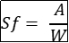Eq.(1)
Stability test
The stability test is a crucial part of emulsion preparation, ensuring product stability and sustainability in both the short and long term at various temperatures during storage. Therefore, long-term stability test was conducted at temperatures of 8°C ± 2°C, 25°C ± 2°C, and 40°C ± 2°C. At various intervals throughout 28 days, colour, phase separation, and emulsion liquefaction were observed, followed by a cycling test in which the physicochemical stability of the cream formulation was examined through six cooling-heating cycles. In every cycle, cream samples were refrigerated for 24 hours, followed by incubation at 45°C for an additional 24 hours (Buranasukhon et al., 2017; Smaoui et al., 2017).
Fourier transform infrared (FTIR) spectrum test.
The sample was placed on the reflection diamond, and its infrared spectra were recorded. The scan range used is 400 cm-1 to 4000 cm-1 with a resolution of 4 cm-1. Each resulting peak indicates the presence of a functional group in the formulation (Li et al., 2024).

Antibacterial activity
The antibacterial activity of the cream emulsion was evaluated using the agar well diffusion method. S. epidermidis was cultured on nutrient agar and standardized to 1 × 10⁸ CFU/mL, corresponding to a 0.5 McFarland standard. The bacterial suspension was prepared from a fresh 24-hour culture and visually adjusted to match the McFarland turbidity tube. To validate the actual bacterial concentration, a serial dilution followed by spread plating was performed on nutrient agar. Colony counts after incubation confirmed that the suspension fell within the acceptable range of 10⁷–10⁸ CFU/mL. Nutrient agar was prepared by dissolving 28 g of agar in 1,000 mL of distilled water, sterilized by autoclaving, and then poured into petri dishes. After solidification, each plate was inoculated with 100 µL of the standardized bacterial suspension and evenly spread using sterile cotton swabs. Wells were created using a 1000 µL micropipette tip, and each plate was divided into three sections: a positive control (gentamicin at 4 µg/mL), a negative control (base formulation without active oils), and the test formulation (cream containing active ingredients at 5 mg/mL). All controls and test samples were introduced into their respective wells, and the plates were incubated at 40°C for 24 hours to observe zones of inhibition. All tests were performed in triplicate to ensure reproducibility (Chen et al., 2016; Vora et al., 2018; Ramdas et al., 2022; Wahyuningrum et al., 2023).

Results
Physical properties of anti-acne moisturizer
Table 2 demonstrates the physical property evaluation of the formulated F1, F2, and F3 moisturizer cream. The pH value for each formulation ranges between 5.59 and 5.73. Besides pH measurement, the physical stability of cream products is typically evaluated based on centrifugation tests, which apply centrifugal force at 3000 rpm. The occurrence of caking, coalescence, and flocculation indicates the presence of phase separation. The cream formulation appears stable, with no sign of phase separation. The spreadability factor of formulations was calculated as 0.62 ±0.01, 0.67 ±0.01 and 0.74± 0.01 mm2g-1. Figure 1 shows the dilution test of F1, F2 and F3 formulations. Based on Figure 1, it can be inferred that the formulation is an oil-in-water formulation because it is miscible with distilled water. Sensitivity test exhibited no visible redness or irritation on the skin. This indicates that the formulated creams were safe and did not cause any sensitivity reactions. More than 70% of the sample weight was lost upon drying for all formulations, which is consistent with their high water content, a common characteristic of topical moisturizers (Mawazi et al., 2022). Based on the results of the washability study conducted on the cream formulations, it can be observed that all three formulations are easily washable, as they are miscible in water. All samples were removed entirely in less than 4 seconds. Based on the organoleptic test, all three samples have a pleasant odour and smooth textures. The F1 cream was observed to be white, while F2 and F3 are slightly yellowish due to the presence of rosehip oil in their composition. All the ingredients in the formulations were found to be homogenized harmoniously, as they do not contain any visible grains. The creams are also non-greasy and cause no noticeable sensation upon testing on the skin.
Based on the microscopic observations (Figure 2), the creams displayed oil droplets that are evenly distributed in size, corresponding to their texture. The study demonstrated that all three cream formulations exhibit non-Newtonian, pseudoplastic behaviour, as evidenced by the non-linear flow curves shown in Figures 3–5. This behaviour indicates that viscosity decreases with increasing shear rate, a characteristic of pseudoplastic systems. The corresponding viscosity profiles (Figures 6–8) further confirm this observation. Pseudoplasticity in topical creams is advantageous because it allows the formulation to spread easily under shear during application, while maintaining stability at rest (Mawazi et al., 2022). Table 3 presents the viscosity values for all formulations that have been prepared. Viscosity for F1 is 8.32 Pa.s ±1.06, while for F2 is 10.02 Pa.s ±0.90 and for F3 is 7.40 Pa.s ±0.75. However, no significant difference in the viscosity of all the formulations.

Table 2: Results for Physicochemical Properties Evaluation of The Moisturizer Cream
Test | Parameter | F1 | F2 | F3
pH measurement ±SD |  | 5.59 ±0.01C | 5.73 ±0.02A | 5.63 ±0.02B
Centrifugation | Phase separation | No separation | No separation | No separation
Spreadability ±SD | Sf (mm²g-1) | 0.62 ± 0.01A | 0.67 ± 0.01A | 0.74 ± 0.01AB
Dilution |  | Dilute in distilled water | Dilute in distilled water | Dilute in distilled water
Sensitivity |  | No irritation or redness | No irritation or redness | No irritation or redness
Loss of drying ±SD | Weight loss (g) | 0.73 ± 0.05A | 0.73 ±0.02A | 0.72 ±0.01A
Loss of drying ±SD | % Weight loss | 70.85 ± 5.56 A | 71.20 ± 6.20 A | 71.79 ± 5.30 A
Washability ±SD | Time taken (s) | 3.34 ±0.03A | 3.11 ±0.01C | 3.24 ±0.02B
Washability ±SD | Observation | Easily washable | Easily washable | Easily washable
Organoleptic | Odour | Pleasant | Pleasant | Pleasant
Organoleptic | Texture | Smooth | Smooth | Smooth
Organoleptic | Colour | White | Yellowish cream | Yellowish cream
Homogeneity | Greasiness | Non-greasy | Non-greasy | Non-greasy
Homogeneity | Skin sensation | No sensation | No sensation | No sensation
Homogeneity | Grittiness | No apparent grains | No apparent grains | No apparent grains
Values with no shared letters vary significantly at p<0.05, SD = standard deviation

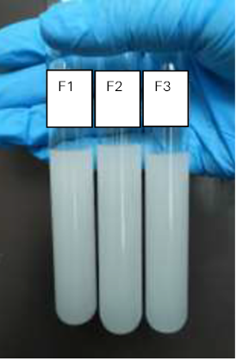
Figure 1: Dilution Test Result of F1, F2 And F3 Formulation

 | Magnification power of 40× | Magnification power of 400×
F1 | 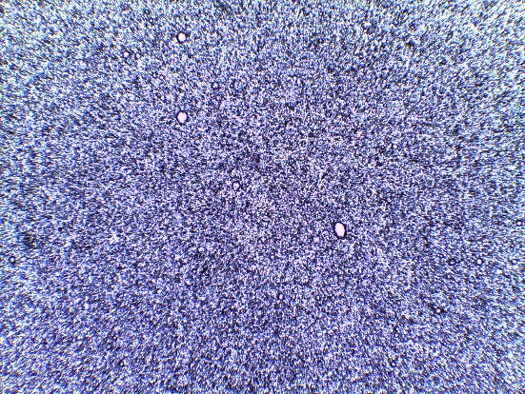 | 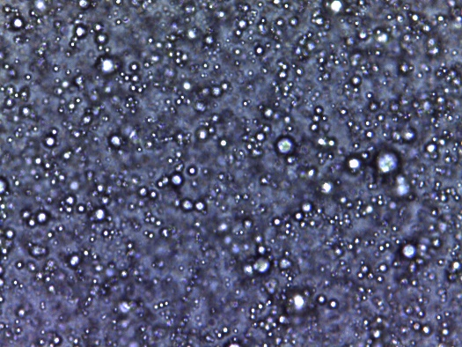
F2 | 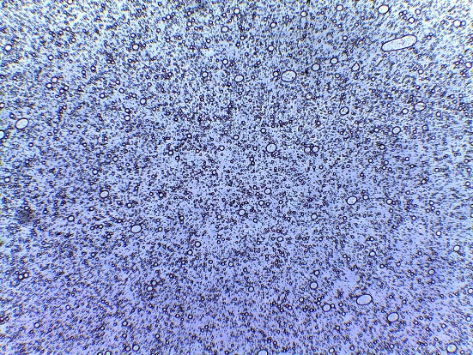 | 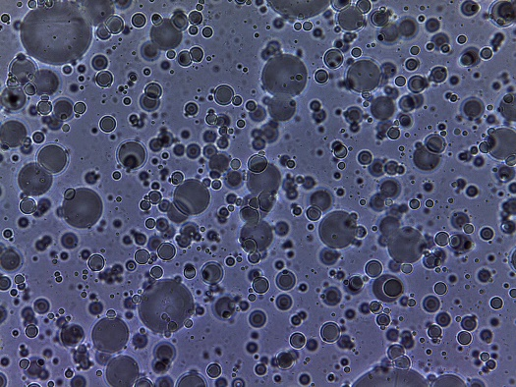
F3 | 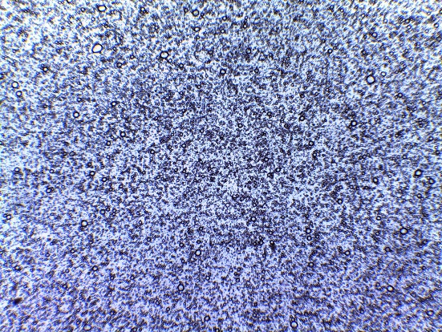 | 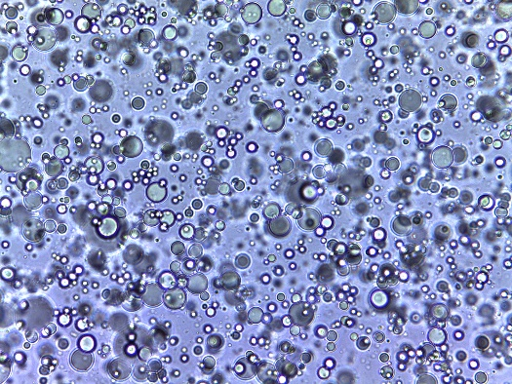
Figure 2: Microscopic Test Results For F1, F2 And F3 Formulation

Figure 3: Graph of Shear Stress Versus Shear Rate F1

Figure 4: Graph of Shear Stress Versus Shear Rate F2

Figure 5: Graph Of Shear Stress Versus Shear Rate F3

Figure 6: Graph of Viscosity Versus Shear Rate F1

Figure 7: Graph of Viscosity Versus Shear Rate F2

Figure 8: Graph of Viscosity Versus Shear Rate F3
Table 3: Results of The Viscosity Test For Three Formulations
Formulation | Viscosity (Pa.s)±SD
F1 | 8.32 ± 1.06AB
F2 | 10.02 ± 0.89A
F3 | 7.40 ± 0.75B
Values with no shared letters vary significantly at p<0.05, SD = standard deviation
Stability Test
The creams were subjected to different temperatures of 8 °C ± 2 °C, 25 °C ± 2 °C, and 40 °C ± 2 °C for 28 days. Likewise, samples were collected at similar temperatures and were taken at specific intervals during the investigation, including on days 3, 7, 14, 21, and 28. These samples were then analyzed for the formulation's pH and appearance. It was observed (Table 4) that the physical appearance of formulations F1, F2, and F3 remained unchanged even after being exposed to various conditions for 28 days. All three observed formulations do not have a separation phase, and their colour remains unchanged. The pH value was measured, and although there was a slight change, it remained within the safe range of 5.5–6.5. The cycling tests were conducted with six storage cycles, changing between 8 °C and 40 ˚C temperatures. After each cycle, the samples were measured for their pH value and visually inspected for appearance (Table 4). The pH values of the creams were measured (Smaoui et al., 2017; Maha et al., 2018).
Table 4: Long-Term Stability Observation Results at The Temperatures of 8 °C, 25 °C And 40 °C
Temperature (8 °C)
Formulation | Day | pH value ±SD | Color | Phase Separation
F1 | 1 | 5.58 ±0.01C | White | No separation
F1 | 3 | 5.55 ±0.01C | White | No separation
F1 | 7 | 5.59 ±0.01B | White | No separation
F1 | 14 | 5.58 ±0.11C | White | No separation
F1 | 21 | 5.59 ±0.00C | White | No separation
F1 | 28 | 5.59 ±0.06C | White | No separation
F2 | 1 | 5.72 ±0.01A | Yellowish cream | No separation
F2 | 3 | 5.73 ±0.02A | Yellowish cream | No separation
F2 | 7 | 5.75 ±0.04A | Yellowish cream | No separation
F2 | 14 | 5.74 ±0.01A | Yellowish cream | No separation
F2 | 21 | 5.74 ±0.02A | Yellowish cream | No separation
F2 | 28 | 5.73 ±0.00A | Yellowish cream | No separation
F3 | 1 | 5.63 ±0.02B | Yellowish cream | No separation
F3 | 3 | 5.64 ±0.01B | Yellowish cream | No separation
F3 | 7 | 5.63 ±0.02B | Yellowish cream | No separation
F3 | 14 | 5.63 ±0.02B | Yellowish cream | No separation
F3 | 21 | 5.64 ±0.02B | Yellowish cream | No separation
F3 | 28 | 5.63 ±0.03B | Yellowish cream | No separation
Values with no shared letters vary significantly at p>0.05, SD = standard deviation
Fourier transform infrared (FTIR) spectrum test
Tables 5, 6, and 7 summarize the functional group classes identified from the FTIR spectra of the three formulations. As FTIR does not provide molecular identification, these results represent the collective contribution of chemical functional groups from the oils and excipients.

Table 5: Classification of The Wavenumber of F1
Wavenumber  (Cm-1) | Compound Class | Functional Group | Vibration Mode
3281 | Intermolecularly bonded alcohol, carboxylic acid | O-H | Stretching
1639 | Alkene, amine | C=C  N-H | Stretching, bending
1413 | Sulfate, alcohol | S=O  O-H | Stretching, bending
1042 | Fluoro compound, amine, sulfoxide, anhydride | C-F  C-N  S=O  CO-O-CO | Stretching
992 | Monosubstituted alkene | C=C | Bending
C- carbon, O-oxygen, N-nitrogen, H-hydrogen, S-sulfur, F-fluorine

Table 6: Classification of the Wavenumber of F2
Wavenumber (cm-1) | Compound Class | Functional Group | Vibration Mode
3281 | Intermolecularly bonded alcohol, carboxylic acid | O-H | Stretching
2192 | Disubstituted alkyne | C≡C | Stretching
2158 | Thiocyanate, azide | S-C≡N  N=N=N | Stretching
1636 | Alkene, amine | C=C  N-H | Stretching, bending
1041 | Fluoro compound, amine, sulfoxide, anhydride | C-F  C-N  S=O  CO-O-CO | Stretching
C- carbon, O-oxygen, N-nitrogen, H-hydrogen, S-sulfur, F-fluorine
Table 7: Classification of The Wavenumber of F3
Wavenumber (cm-1) | Compound Class | Functional Group | Vibration Mode
3272 | Intermolecularly bonded alcohol, carboxylic acid | O-H | Stretching
2170 | Thiocyanate | S-C≡N | Stretching
1637 | Alkene, amine | C=C  N-H | Stretching, bending
1413 | Sulfate, alcohol | S=O  O-H | Stretching, bending
1042 | Fluoro compound, amine, sulfoxide, anhydride | C-F  C-N  S=O  CO-O-CO | Stretching
992 | Monosubstituted alkene | C=C | Bending
C- carbon, O-oxygen, N-nitrogen, H-hydrogen, S-sulfur, F-fluorine
Formulation 1 (F1), containing avocado oil as the active ingredient, shows characteristic absorption bands corresponding to intermolecular-bonded alcohols (O–H), carboxylic acids (C=O), alkenes (C=C), amines (N–H), sulfates (S=O), and sulfoxides (S=O). These functional groups are consistent with the fatty acids, sterols, and emulsifying agents present in the formulation. Formulation 2 (F2), which incorporates rosehip oil, exhibits similar categories of functional groups, including intermolecular hydrogen-bonded alcohols, carboxylic acids, alkynes, thiocyanates, azides, alkenes, and amines, reflecting the presence of polyunsaturated fatty acids and formulation excipients. Formulation 3 (F3) demonstrates functional groups such as alcohols, carboxylic acids, thiocyanates, alkenes, amines, sulfates, sulfoxides, and anhydrides, indicating overlapping contributions from both plant oils and formulation additives.
Antibacterial activity test
The agar well diffusion method was used to determine the diameter of the inhibitory zone. This was done by observing and measuring the diameter of the clear zone. According to the findings presented in Table 8, only the positive control exhibits an inhibition zone with a value of 30.67 mm ± 1.16. The test used gentamicin antibiotic as the positive control. No zone inhibition was observed when testing the resulting formulation for antibacterial activity.
Table 8: Antibacterial Activity Results (Inhibition Zone of Cream Formulation Against S. Epidermidis
 | Control | Diameter of the inhibition zone  (mm ±SD)
F1 | Positive control (Gentamicin) | 30.67 ±1.16A
F1 | Negative control (Formulation without active ingredients) | No inhibition zone
F1 | Formulation 1 (Contains avocado oil) | No inhibition zone
F2 | Positive control (Gentamicin) | 29.33 ±1.16AB
F2 | Negative control (Formulation without active ingredients) | No inhibition zone
F2 | Formulation 2 (Contains rosehip oil) | No inhibition zone
F3 | Positive control (Gentamicin) | 26.33 ±2.30B
F3 | Negative control (Formulation without active ingredients) | No inhibition zone
F3 | Formulation 3 (Contains avocado oil and rosehip oil) | No inhibition zone
Values with no shared letters vary significantly at p<0.05, SD = standard deviation

Discussion
Based on physical property analyses, topical preparations should have a pH range of 4.5 to 6.5, corresponding to the skin's natural pH, where the results fall within the ideal range (Maha et al., 2018). The study by Mawazi et al. (2022), stated that if the pH of the topical preparation is too acidic or alkaline, it can cause skin irritation. Meanwhile, the cream formulation appears stable, as there is no sign of phase separation, indicating that all the ingredients have been completely blended. The spreadability values refer to the ability of the formulations to easily spread on the application surface with a small amount of shear. The spreadability of semisolid formulations, or the ability of cream to be spread evenly on the skin, is a key factor in delivering a standard drug dose to the skin and the effectiveness of a topical treatment (Chen et al., 2016). Mohamed et al. (2020) stated that the spreadability coefficient of the cream, which has a low value, suggests that the cream is easy to spread. Nurman et al. (2019) state that for an emulsion to be effectively distributed on the skin, it must possess good spreadability, typically within the 5-7 cm range. A lower spreadability value suggests that the cream can be easily spread over the skin with minimal effort. The results indicate that the formulation is highly spreadable and can be applied with minimal shear. All three oil-in-water formulations were observed to be miscible in the distilled water. Diluting an oil-in-water emulsion can be easily achieved by using an aqueous solvent.
Rheology studies the processes involved in producing and applying semisolid topically applied compositions. Rheological characteristics are crucial in determining the physical stability of a formulation during its shelf life. Non-Newtonian fluids are known to display complicated behaviour. The non-Newtonian behaviour was confirmed by the non-linear shear stress–shear rate curves and the decreasing viscosity trend with increasing shear rate in the graphs. These patterns indicate pseudoplastic behaviour. This shear-dependent viscosity is desirable because it enables easy spreading during application and maintains a higher viscosity at rest, thereby improving stability and the overall user experience. The study displayed characteristics desirable in pharmaceutical and cosmetic products that are used topically.
Viscosity is an important characteristic of fluids that measures their ability to resist deformation or flow when subjected to shear stress. The knowledge of viscosity is crucial in various professions and industries because it provides valuable information about the behaviour and performance of fluids. The relationship between the deformation rate and shear stress in non-Newtonian fluids is more complex. A fluid that does not follow Newton's law of viscosity is classified as having a non-Newtonian viscosity. According to Newton's law, there is a directly proportional relationship between the shear stress, the force per unit area, the rate of shear strain, and the velocity gradient experienced by a fluid. The microscopic observations of an oil-in-water emulsion consist of two distinct phases: the dispersed phase and the continuous phase. The term "dispersed phase" refers to the tiny droplets of oil suspended in the continuous phase, the water phase. The dispersed phase consists of small droplets or particles of oil that are uniformly distributed throughout the water medium (Deuschle et al., 2015; Chaudhari et al., 2025).
Typically, the topical cream's stability should be tested at different temperature storage conditions to ensure its quality. According to Kirkbride et al (2021), the objective of conducting long-term stability testing on cosmetic products is to assess their quality and effectiveness throughout their intended shelf life, typically 12 months or longer. All three observed formulations do not have a separation phase, and their colour remains unchanged. The pH value was measured, and although there was a slight change, it still fell within the safe range of 5.5-6.5 (Dantas et al., 2016). The cycling stability test was developed to assess a product's ability to withstand repeated or cyclic changes in environmental conditions and evaluate its performance and durability. A cycling test is a valuable tool in determining a product's performance under real-life conditions that it may encounter during its use or storage. This test can effectively identify potential failures or degradation over time (Anand et al., 2021). In a study conducted by Weingarth et al. (2013), performing a cycling test can help identify the most effective operational range and limitations of a product. The pH values obtained during the cycling test remained within the range of 5.5 to 6.5. Based on the physical stability observations over six cycles, it can be concluded that the cream formulation is stable. This is supported by the fact that the colour of all formulations remained unchanged, and no phase separation was observed.
The FTIR is a highly versatile analytical technique that is widely utilized. This technique can offer valuable insights into the molecular structure of both organic and inorganic components. This method is frequently used for chemical characterization and is non-destructive. Chen et al (2015) explain that the FTIR technique detects transitions between quantized vibrational energy states. According to Parikh and Chorover (2005), during FTIR analysis, a molecule absorbs infrared (IR) radiation when it receives a photon, which causes it to become excited and move to a higher energy state. Molecules in an excited state exhibit various movements, including stretching, bending, twisting, rocking, wagging, and out-of-plane deformation, resulting from the vibration of their bonds. Vibrations occur at different frequencies or wavenumbers within the light spectrum's IR (ion). Each IR absorbance peak appears at a specific wavenumber based on the fundamental vibrational properties of the molecule, which are governed by the type of chemical bonds, their strengths, and the functional groups present. Chen et al (2015) stated that this tool functions as a diagnostic tool, like a fingerprint, for identifying the corresponding functional group. Various functional groups corresponding to the active ingredients used were observed to confirm the physical attributes of the formulations.
The absence of inhibition observed in our formulations may be due to the concentration of active constituents being below the effective antibacterial threshold. Similar studies have used other plant extracts, such as Rosa spp. (MIC 3.125–500 mg/mL) and avocado peel or basil leaf extracts tested at multiple concentrations demonstrate that sufficiently high concentrations are typically necessary to achieve measurable antibacterial activity (Milala et al., 2021; Susanti et al., 2024). Thus, this study can be considered preliminary findings for future studies.

Conclusion
Stable topical emulsions containing rosehip and avocado oils were successfully developed, exhibiting skin-friendly pH, excellent spreadability, and desirable pseudoplastic flow for smooth application. The formulations remained stable under varied conditions, confirming their suitability for cosmetic use. Although no antibacterial activity against S. epidermidis was observed, the creams demonstrate promise as safe and effective moisturisers, with potential for enhanced functionality through higher concentrations or additional actives.
Conflicts of Interest
The authors declared that they have not any conflict of interest.

Acknowledgement
The authors thank the Management and Science University, Shah Alam and Faculty of Pharmacy and Health Sciences, Royal College of Medicine Perak, Universiti Kuala Lumpur for supporting the study.

References
Anand, A., Shukla, A., Kumar, A., Buddhi, D., & Sharma, A. (2021). Cycle test stability and corrosion evaluation of phase change materials used in thermal energy storage systems. Journal of Energy Storage, 39, 102664. https://doi.org/10.1016/j.est.2021.102664
Buranasukhon, W., Athikomkulchai, S., Tadtong, S., & Chittasupho, C. (2017). Wound healing activity of Pluchea indica leaf extract in oral mucosal cell line and oral spray formulation containing nanoparticles of the extract. Pharmaceutical Biology, 55(1), 1767-1774. https://doi.org/10.1080/13880209.2017.1326511
Chaudhari, R. M., Chaudhari, R. S., & Deore, K. R. (2025). Formulation and Evaluation of Herbal Moisturizing Cream. International Journal of Research in Pharmacy and Allied Science, 4(5), 186-191. https://doi.org/10.22159/ijpps.2018v10i11.28645
Chen, M. X., Alexander, K. S., & Baki, G. (2016). Formulation and evaluation of antibacterial creams and gels containing metal ions for topical application. Journal of Pharmaceutics, 2016, 5754349. https://doi.org/10.1155/2016/5754349
Chen, Y., Zou, C., Mastalerz, M., Hu, S., Gasaway, C., & Tao, X. (2015). Applications of micro-fourier transform infrared spectroscopy (FTIR) in the geological sciences—a review. International Journal of Molecular Sciences, 16(12), 30223-30250. https://doi.org/10.3390/ijms161226227
Chien, A. L., Qi, J., Rainer, B., Sachs, D. L., & Helfrich, Y. R. (2016). Treatment of acne in pregnancy. The Journal of the American Board of Family Medicine, 29(2), 254-262. https://doi.org/10.3122/jabfm.2016.02.150165
Chularojanamontri, L., Tuchinda, P., Kulthanan, K., & Pongparit, K. (2014). Moisturizers for acne: What are their constituents?. Journal of Clinical and Aesthetic Dermatology, 7(5), 36-44. https://jcadonline.com/moisturizers-for-acne-what-are-their-constituents/
Dantas, M. G. B., Reis, S. A. G. B., Damasceno, C. M. D., Rolim, L. A., Rolim-Neto, P. J., Carvalho, F. O., ... & Almeida, J. R. G. D. S. (2016). Development and evaluation of stability of a gel formulation containing the monoterpene borneol. The Scientific World Journal, 2016(1), 7394685. https://doi.org/10.1155/2016/7394685
Deuschle, V. C. K. N., Deuschle, R. A. N., Bortoluzzi, M. R., & Athayde, M. L. (2015). Physical chemistry evaluation of stability, spreadability, in vitro antioxidant, and photo-protective capacities of topical formulations containing Calendula officinalis L. leaf extract. Brazilian Journal of Pharmaceutical Sciences, 51(1), 63-75. https://doi.org/10.1590/S1984-82502015000100007
Dréno, B., Blouin, E., Moyse, D., Bodokh, I., Knol, A. C., & Khammari, A. (2014). Acne in pregnant women: a French survey. Acta Dermato-Venereologica, 94(1), 82-83. https://doi.org/10.2340/00015555-1594
Gyawali, R., Gupta, R. K., Shrestha, S., Joshi, R., & Paudel, P. N. (2020). Formulation and evaluation of polyherbal cream containing cinnamomum Zeylanicum Blume, Glycyrrhiza glabra L and Azadirachta indica A. Juss. extracts to topical use. Journal of Institute of Science and Technology, 25(2), 61-71. https://doi.org/10.3126/jist.v25i2.33738
Hafeez, A., Ahmad, S., & Al-Taie, A. (2020). Elucidating anti-acne properties of a novel herbal moisturizer. Journal of Pharmaceutical Research International, 32(35), 22-27. https://doi.org/10.9734/JPRI/2020/v32i3530976
Hamann, T., Brüggemann, H., Feidenhansl, C., Rruci, E., Gallinger, J., Gallinat, S., & Hüpeden, J. (2025). Distinct intraspecies variation of Cutibacterium acnes and Staphylococcus epidermidis in acne vulgaris and healthy skin. Microorganisms, 13(2), 299. https://doi.org/10.3390/microorganisms13020299
Milala, J., Piekarska-Radzik, L., Sójka, M., Klewicki, R., Matysiak, B., & Klewicka, E. (2021). Rosa spp. extracts as a factor that limits the growth of Staphylococcus spp. bacteria, a food contaminant. Molecules, 26(15), 4590. https://doi.org/10.3390/molecules26154590
Kirkbride, L., Humphries, L., Kozielska, P., & Curtis, H. (2021). Designing a suitable stability protocol in the face of a changing retail landscape. Cosmetics, 8(3), 64. https://doi.org/10.3390/cosmetics8030064
Li, Z., Xu, Y., Liu, Y., Kong, M., Ma, K., Wang, J., ... & Zhao, Y. (2024). Ultrasonic pretreatment combined with microwave-assisted hydrodistillation for the situ extraction of essential oil from Pinus koraiensis seed scales induced by tea saponin: functional activity, composition, thermal stability and material characterization. Industrial Crops and Products, 210, 118191. https://doi.org/10.1016/j.indcrop.2024.118191
Lin, T. K., Zhong, L., & Santiago, J. L. (2018). Anti-inflammatory and skin barrier repair effects of topical application of some plant oils. International Journal of Molecular Sciences, 19(1), 70. https://doi.org/10.3390/ijms19010070
Maha, H. L., Sinaga, K. R., & Masfria, M. (2018). Formulation and evaluation of miconazole nitrate nanoemulsion and cream. Asian Journal of Pharmaceutical and Clinical Research, 11(3), 319-321. http://dx.doi.org/10.22159/ajpcr.2018.v11i3.22056
Mawazi, S. M., Ann, J., Othman, N., Khan, J., Alolayan, S. O., Thagfan, S. S. A., & Kaleemullah, M. (2022). A review of moisturizers; history, preparation, characterization and applications. Cosmetics, 9(3), 61. https://doi.org/10.3390/cosmetics9030061
Mohamed, A. S., Fahmy, S. R., & Elsayed, A. A. (2020). Formulation and Evaluation of the sea cucumber, Holothuria arenicola extract incorporated skin cream. GSC Biological and Pharmaceutical Sciences, 13(2), 232–239. https://doi.org/10.30574/gscbps.2020.13.2.0379
Novaryatiin, S., Nuramanah, R., Isnawati, I., Susanti, S., Kanahuang, D. S. R., & Ardhany, S. D. (2024). Formulation, physical characterization, and antibacterial activity of modifications of Bawang Dayak Eleutherine bulbosa (Mill.) Urb. anti-acne cream. Journal of Herbal Medicine, 45, 100869. https://doi.org/10.1016/j.hermed.2024.100869
Nurman, S., Yulia, R., Irmayanti, Noor, E., & Candra Sunarti, T. (2019). The optimization of gel preparations using the active compounds of arabica coffee ground nanoparticles. Scientia Pharmaceutica, 87(4), 32. https://doi.org/10.3390/scipharm87040032
Parikh, S. J., & Chorover, J. (2005). FTIR spectroscopic study of biogenic Mn-oxide formation by Pseudomonas putida GB-1. Geomicrobiology Journal, 22(5), 207-218. https://doi.org/10.1080/01490450590947724
Pugashetti, R., & Shinkai, K. (2013). Treatment of acne vulgaris in pregnant patients. Dermatologic Therapy, 26(4), 302-311. https://doi.org/10.1111/dth.12077
Ramdas, R. S., Rasny, M. R. M., Xian, B. T. S., Kaleemullah, M., Khan, J., & Asmani, F. (2022). Evaluation of antioxidant and antibacterial activity of ethanolic leaf and stem extract of IPOMOEA aquatica against skin infection. International Journal of Medical Toxicology & Legal Medicine, 25(3and4), 7-13. https://doi.org/10.5958/0974-4614.2022.00043.2
Rau, A., Keri, J., & Murase, J. E. (2024). Management of acne in pregnancy. American Journal of Clinical Dermatology, 25(3), 465-471. https://doi.org/10.1007/s40257-024-00851-6
Smaoui, S., Hlima, H. B., Chobba, I. B., & Kadri, A. (2017). Development and stability studies of sunscreen cream formulations containing three photo-protective filters. Arabian Journal of Chemistry, 10(Supp 1), S1216-S1222. https://doi.org/10.1016/j.arabjc.2013.02.020
Susanti, S., & Asri, M. T. (2024). Antibacterial activity of avocado peel extract and basil leaves against Staphylococcus epidermidis. LenteraBio: Berkala Ilmiah Biologi, 13(2), 236-243. https://doi.org/10.26740/lenterabio.v13n2.p236-243
Tan, A. U., Schlosser, B. J., & Paller, A. S. (2018). A review of diagnosis and treatment of acne in adult female patients. International Journal of Women's Dermatology, 4(2), 56-71. https://doi.org/10.1016/j.ijwd.2017.10.006
Jones, S. V., Ambros-Rudolph, C., & Nelson-Piercy, C. (2014). Skin disease in pregnancy. Bmj, 348. https://doi.org/10.1136/bmj.g3489
Vora, J., Srivastava, A., & Modi, H. (2018). Antibacterial and antioxidant strategies for acne treatment through plant extracts. Informatics in Medicine unlocked, 13, 128-132. https://doi.org/10.1016/j.imu.2017.10.005
Wahyuningrum, R., Rahayu, W. S., Kaleemullah, M., Fitriani, A. R., & Hapsari, I. (2023). Antibacterial activity clay liquid soap of combination bentonite and pineapple peel ethanolic extract (Ananas Comosus (L.) Merr.) against pseudomonas aeruginosa and bacillus subtilis. Current Trends in Biotechnology & Pharmacy, 17. https://openurl.ebsco.com/EPDB%3Agcd%3A8%3A20224504/detailv2?sid=ebsco%3Aplink%3Ascholar&id=ebsco%3Agcd%3A169859844&crl=c&link_origin=scholar.google.com
Weingarth, D., Foelske-Schmitz, A., & Kötz, R. (2013). Cycle versus voltage hold–Which is the better stability test for electrochemical double layer capacitors?. Journal of Power Sources, 225, 84-88. https://doi.org/10.1016/j.jpowsour.2012.10.019
Xu, W., Xu, J., Huang, D., Wang, C., Song, J., Chen, X., & Suo, H. (2025). Acne vulgaris: advances in pathogenesis and prevention strategies. European Journal of Clinical Microbiology & Infectious Diseases, 44(3), 515-532. https://doi.org/10.1007/s10096-024-04984-8

